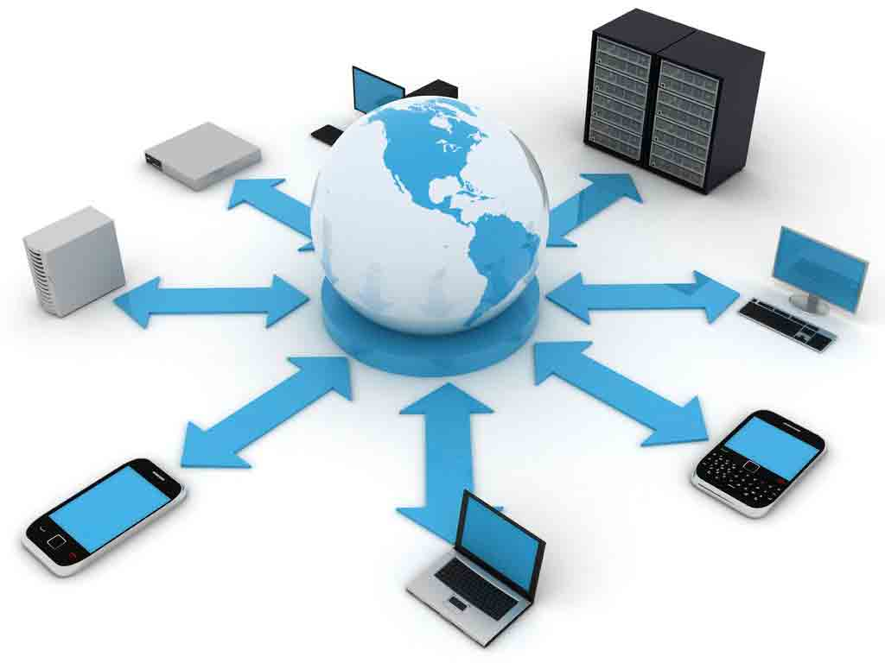The OSI Model

*Figure 1.* Local Area Network. This figure shows a simple topography of the Local Area Network.

Reprinted from “Computer Networks: Local Area Networks and Wider Area Networks” by S, Samiksha, 22 Feb. 2014, http://www.yourarticlelibrary.com/information-technology/computer-networks-local-area-networks-and-wider-area-networks/10454

Zachary E. M. Burson

University of Maryland University College

June 2018

**What is the OSI Model?**

OSI Model stands for Open Systems Interconnection Model and is a conceptual outline for how information is processed from your input and transmitted across the internet (Shaw, 2017). The model consists of 7 layers and is the foundation for how computers communicate over the network. It was created by the International Organization for Standardization (ISO) and all network components—modems, routers, switches—follow this framework design (Shaw, 2017). If this model wasn’t followed, devices would have difficulty communicating with each other and possibly wouldn’t communicate at all. The layers are often memorized through a pneumonic that goes:

**A**ll **P**eople **S**eem **T**o **N**eed **D**ata **P**rocessing *OR* **P**lease **D**o **N**ot **T**hrow **S**ausage **P**izza **A**way

It starts from the top—**A**pplication, **P**resentation, **S**ession, **T**ransport, **N**etwork, **D**ata Link, and **P**hysical—then it is reversed (Shaw, 2017).

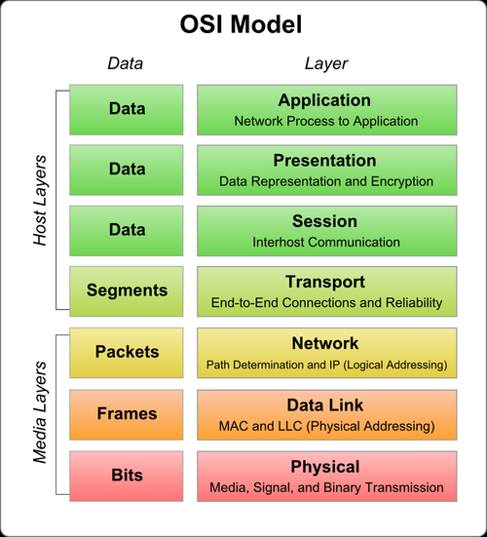

*Figure 2.* The OSI Model. This figure shows the different layers of the model.

Reprinted from “Are You Connected?” by Moseley, Saskia, *#CSS*, 17 Oct. 2016, cssuwi.org/are-you-connected/.

**How Does the OSI Model Work?**

The model consists of 7 layers, that take the information you input and “encapsulates”, or combines, the information at each layer. Once the information is encapsulated, it can then travel over the network to the receiver, where the information then “decapsulates”, or separates, and moves back up the layers in its original form (Sriman). Once it has been decapsulated, the receiver can read the information just like you input it.

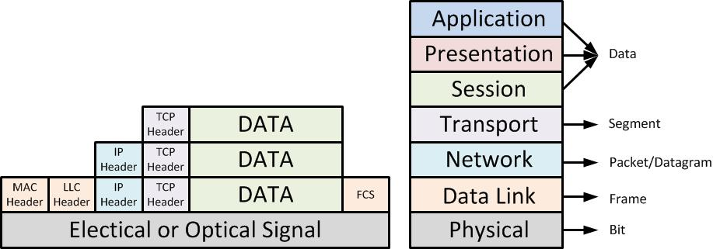

*Figure 3.* Encapsulation/Decapsulation. This figure shows how data is encapsulated from the top layer of the OSI model, transmitted, and then decapsulated from the bottom layer of the OSI model.

Reprinted from “Encapsulation (networking)” by en:User:Cburnett original work, colorization by en:User:Kbrose - Original artwork by en:User:Cburnett, CC BY-SA 3.0, https://commons.wikimedia.org/w/index.php?curid=1546338

**Encapsulation**

**Decapsulation**

**Layer 7 – Application Layer**



*Figure 4.* OSI Model. This figure summarizes the Application Layer

Adapted from “osi-model” by LoveToKnow Corp, n.d. http://www.yourdictionary.com/osi-model

This is what you see when you open the internet. This is the interface that you interact with on websites, such as buttons, links, text fields, etc (The OSI Model - What It Is; Why It Matters; Why It Doesn't Matter.). The actions that you perform on the website start the data encapsulation process and transmit that information to the server or database and await the response.

**Layer 6 – Presentation Layer**



*Figure 5.* OSI Model. This figure summarizes the Presentation Layer

Adapted from “osi-model” by LoveToKnow Corp, n.d. http://www.yourdictionary.com/osi-model

The presentation layer reads the format in which the data should travel and converts it into the required format. It is similar to a translator. Imagine that you want to speak to someone in French, but don’t know French. This layer is the mediator that transcribes English to French, and from French, back to English.

**Layer 5 – Session Layer**



*Figure 6.* OSI Model. This figure summarizes the Session Layer

Adapted from “osi-model” by LoveToKnow Corp, n.d. http://www.yourdictionary.com/osi-model

The session layer creates a “session” between two devices (The OSI Model - What It Is; Why It Matters; Why It Doesn't Matter.). It asks the device on the opposite end if they would like to speak with you. If the other device responds with a yes, the session is created and the two devices can speak freely between each other. This happens often when you receive “404 Not Found” while searching for a webpage that no longer exists. If you try to contact a webpage, but the webpage does not respond, the session is never created and you receive this error message (The OSI Model - What It Is; Why It Matters; Why It Doesn't Matter.).

**Layer 4 – Transport Layer**



*Figure 7.* OSI Model. This figure summarizes the Transport Layer

Adapted from “osi-model” by LoveToKnow Corp, n.d. http://www.yourdictionary.com/osi-model

The transport layer is responsible for ensuring all information is in the correct package, error-free; it is the quality control of the model. This layer also decides which transport method will be used to transport the information (Kroon & Gattine, 2018). There are two transport methods: **Transmission Control Protocol** (TCP) and **User Datagram Protocol** (UDP).

**TCP** creates what is known as a 3-way-handshake between two devices (Daemon, 2018). It calls out to the receiver and requests a handshake. The receiver then responds if it would like to handshake. Once the response returns to the sender, it sends out another message requesting to transport the information (Daemon, 2018). This method is important to ensure the information gets to the correct receiver with little or no errors.

**UDP** on the other hand doesn’t care if the information even gets to the receiver (Hoffman, 2017). It checks the information you want to send, where you want to send it, and sends it. Sometimes the information doesn’t get to the receiver you would like to and it gets lost in the transmission (Hoffman, 2017). You might wonder why UDP is used if you have the potential to lose information; because it’s faster. A lot of streaming and Voice Over Internet Protocol (VOIP) uses UDP to send information because it is faster and a loss of information doesn’t affect the overall message (Hoffman, 2017).

**Layer 3 – Network Layer**

*Figure 8.* OSI Model. This figure summarizes the Network Layer

Adapted from “osi-model” by LoveToKnow Corp, n.d. http://www.yourdictionary.com/osi-model



The network layer is where your router begins. It assigns Internet Protocol (IP) addresses and creates address tables that direct traffic for the information (Shaw, 2017). This is like the traffic director on a busy street. When you search for websites on the internet, you are searching for an IP address. This layer finds that address for you.

**Layer 2 – Data Link Layer**



*Figure 9.* OSI Model. This figure summarizes the Data Link Layer

Adapted from “osi-model” by LoveToKnow Corp, n.d. http://www.yourdictionary.com/osi-model

The data link layer is another error checking layer that is the last stop before going through the network (Verma, 2012). This layer is at your computer level and is associated with the Media Access Control (MAC) and Logical Link Control (LLC) addresses (Verma, 2012). Each Network Interface Card (NIC) has a uniquely assigned MAC address. This is how computers know that the information goes to the exactly correct device. The IP address is like the street you live on, and the MAC address is like your house number.

**Layer 1 – Physical Layer**



*Figure 10.* OSI Model. This figure summarizes the Physical Layer

Adapted from “osi-model” by LoveToKnow Corp, n.d. http://www.yourdictionary.com/osi-model

This is where the data meets the physical components of the network. From this point, the data travels through the network cables to reach its destination; another user, server, or database (Verma, 2012). It travels through many routers and switches to reach its destination possibly all over the world.

**Message Delivery**

Once all of these layers have encapsulated and decapsulated, the transfer of data between devices is complete. These layers work together at lightning speed to ensure that the information that you want to send is error-free, complete, and sent to the correct destination. It’s amazing how much information is being sent across the network at any given time, all across the world, in fractions of a second.

# Bibliography

Daemon, I. (2018, May 19). TCP 3-Way Handshake (SYN,SYN-ACK,ACK). Retrieved from Routing vs. Routed Protocols - InetDaemon's IT Tutorials: http://www.inetdaemon.com/tutorials/internet/tcp/3-way_handshake.shtml

Hoffman, C. (2017, July 3). What's the Difference Between TCP and UDP? Retrieved from How-To Geek: https://www.howtogeek.com/190014/htg-explains-what-is-the-difference-between-tcp-and-udp/

Kroon, D., & Gattine, K. (2018, April). What is OSI Model (Open Systems Interconnection)? - Definition from WhatIs.com. Retrieved from Search Networking: https://searchnetworking.techtarget.com/definition/OSI

Shaw, K. (2017, December 4). The OSI Model Explained: How to Understand (and Remember) the 7 Layer Network Model. Retrieved from Network World: https://www.networkworld.com/article/3239677/lan-wan/the-osi-model-explained-how-to-understand-and-remember-the-7-layer-network-model.html

Sriman, B. (n.d.). What is Encapsulation in Computer Networking? Retrieved from Computer Networking Demystified: http://computernetworkingsimplified.in/category-1/layering/encapsulation-decapsulation/

The OSI Model - What It Is; Why It Matters; Why It Doesn't Matter. (n.d.). Retrieved from Tech-FAQ: http://www.tech-faq.com/osi-model.html

Verma, V. (2012, March 30). Concept of Open Systems Interconnection (OSI) Model in Networking. Retrieved from C# Corner: www.c-sharpcorner.com/UploadFile/898089/concept-of-open-systems-interconnection-osi-model-in-netwo/